TOPIC 2

Experiment 1
Aim:
As specified in the uploaded experiment sheet.
Algorithm:
1. Read input.
2. Apply the required algorithm.
3. Display the result.
Pseudocode:
START
Read input
Process using algorithm
Print output
STOP
Python Program:
def selection_sort(arr):
n = len(arr)

for i in range(n):
min_index = i

for j in range(i + 1, n):
if arr[j] < arr[min_index]:
min_index = j

arr[i], arr[min_index] = arr[min_index], arr[i]

return arr

# Test Cases
test_cases = [
[],
[1],
[7, 7, 7, 7],
[-5, -1, -3, -2, -4]
]

for arr in test_cases:
print("Input :", arr)
print("Output:", selection_sort(arr.copy()))
print()

Sample Input:
Test Case 1:
[]

Test Case 2:
[1]

Test Case 3:
[7, 7, 7, 7]

Test Case 4:
[-5, -1, -3, -2, -4]

Sample Output:
Test Case 1:
[]

Test Case 2:
[1]

Test Case 3:
[7, 7, 7, 7]

Test Case 4:
[-5, -4, -3, -2, -1]

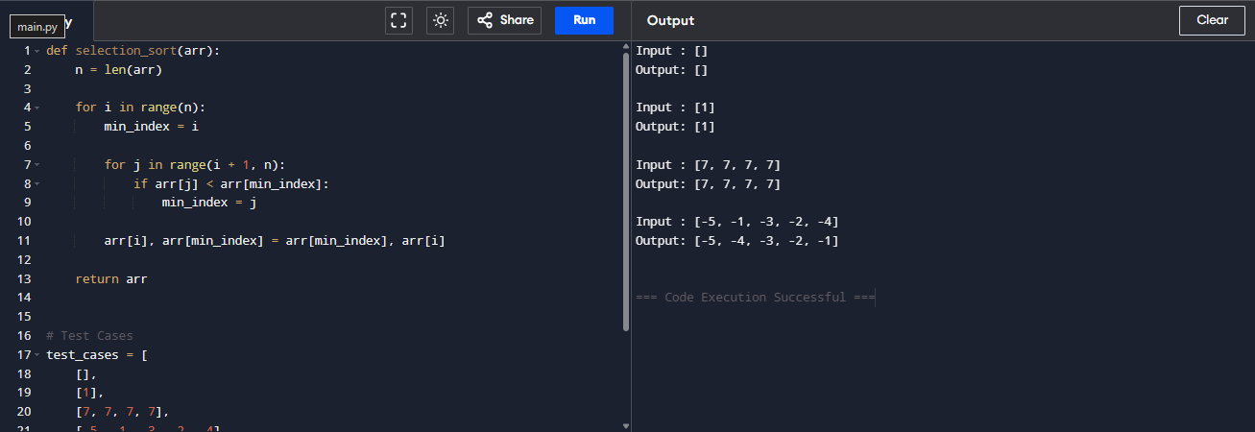
Result:
The program was executed successfully and the expected output was obtained.

Experiment 2
Aim:
As specified in the uploaded experiment sheet.
Algorithm:
1. Read input.
2. Apply the required algorithm.
3. Display the result.
Pseudocode:
START
Read input
Process using algorithm
Print output
STOP
Python Program:
def selection_sort(arr):
n = len(arr)

for i in range(n):
min_index = i

for j in range(i + 1, n):
if arr[j] < arr[min_index]:
min_index = j

arr[i], arr[min_index] = arr[min_index], arr[i]

return arr

# Test Cases
arrays = [
[5, 2, 9, 1, 5, 6],
[10, 8, 6, 4, 2],
[1, 2, 3, 4, 5]
]

for arr in arrays:
print("Input :", arr)
print("Sorted:", selection_sort(arr.copy()))
print()

Sample Input:
Test Case 1:
[5, 2, 9, 1, 5, 6]

Test Case 2:
[10, 8, 6, 4, 2]

Test Case 3:
[1, 2, 3, 4, 5]

Sample Output:
Test Case 1:
[1, 2, 5, 5, 6, 9]

Test Case 2:
[2, 4, 6, 8, 10]

Test Case 3:
[1, 2, 3, 4, 5]

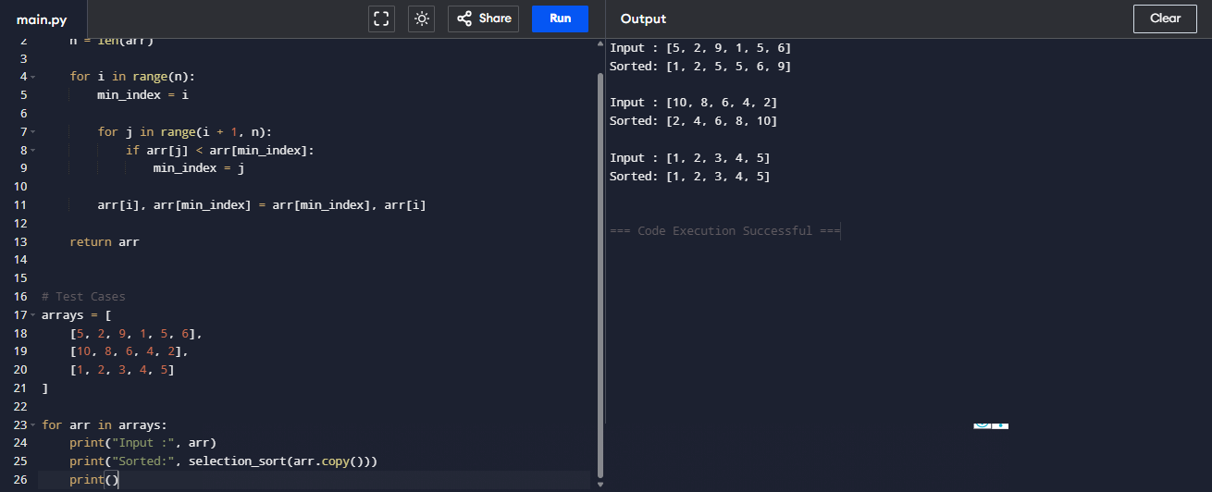

Result:
The program was executed successfully and the expected output was obtained.

Experiment 3
Aim:
As specified in the uploaded experiment sheet.
Algorithm:
1. Read input.
2. Apply the required algorithm.
3. Display the result.
Pseudocode:
START
Read input
Process using algorithm
Print output
STOP
Python Program:
def bubble_sort(arr):
n = len(arr)

for i in range(n):
swapped = False

for j in range(n - i - 1):
if arr[j] > arr[j + 1]:
arr[j], arr[j + 1] = arr[j + 1], arr[j]
swapped = True

if not swapped:
break

return arr

# Test Cases
tests = [
[64, 25, 12, 22, 11],
[29, 10, 14, 37, 13],
[3, 5, 2, 1, 4],
[1, 2, 3, 4, 5],
[5, 4, 3, 2, 1]
]

for arr in tests:
print("Input :", arr)
print("Sorted:", bubble_sort(arr.copy()))
print()

Sample Input:
Test Case 1:
[64, 25, 12, 22, 11]

Test Case 2:
[29, 10, 14, 37, 13]

Test Case 3:
[3, 5, 2, 1, 4]

Test Case 4:
[1, 2, 3, 4, 5]

Test Case 5:
[5, 4, 3, 2, 1]

Sample Output:
Test Case 1:
[11, 12, 22, 25, 64]
Test Case 2:
[10, 13, 14, 29, 37]
Test Case 3:
[1, 2, 3, 4, 5]
Test Case 4:
[1, 2, 3, 4, 5]
Test Case 5:
[1, 2, 3, 4, 5]
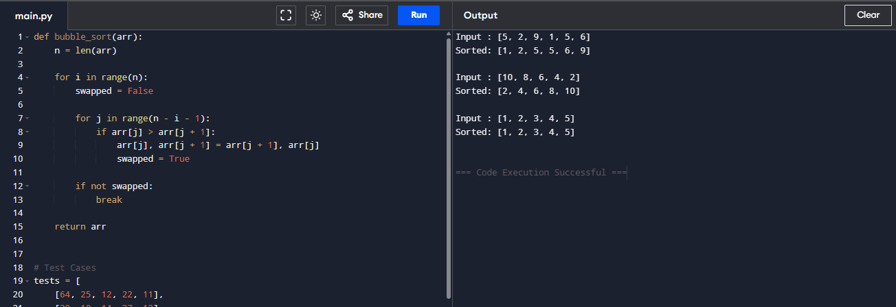
Result:
The program was executed successfully and the expected output was obtained.

Experiment 4
Aim:
As specified in the uploaded experiment sheet.
Algorithm:
1. Read input.
2. Apply the required algorithm.
3. Display the result.
Pseudocode:
START
Read input
Process using algorithm
Print output
STOP
Python Program:
def insertion_sort(arr):

for i in range(1, len(arr)):
key = arr[i]
j = i - 1

while j >= 0 and arr[j] > key:
arr[j + 1] = arr[j]
j -= 1

arr[j + 1] = key

return arr

# Test Cases
arrays = [
[3, 1, 4, 1, 5, 9, 2, 6, 5, 3],
[5, 5, 5, 5, 5],
[2, 3, 1, 3, 2, 1, 1, 3]
]

for arr in arrays:
print("Input :", arr)
print("Sorted:", insertion_sort(arr.copy()))
print()

Sample Input:
Test Case 1:
[64, 25, 12, 22, 11]

Test Case 2:
[29, 10, 14, 37, 13]

Test Case 3:
[3, 5, 2, 1, 4]

Test Case 4:
[1, 2, 3, 4, 5]

Test Case 5:
[5, 4, 3, 2, 1]

Sample Output:
Test Case 1:
[11, 12, 22, 25, 64]

Test Case 2:
[10, 13, 14, 29, 37]

Test Case 3:
[1, 2, 3, 4, 5]

Test Case 4:
[1, 2, 3, 4, 5]

Test Case 5:
[1, 2, 3, 4, 5]
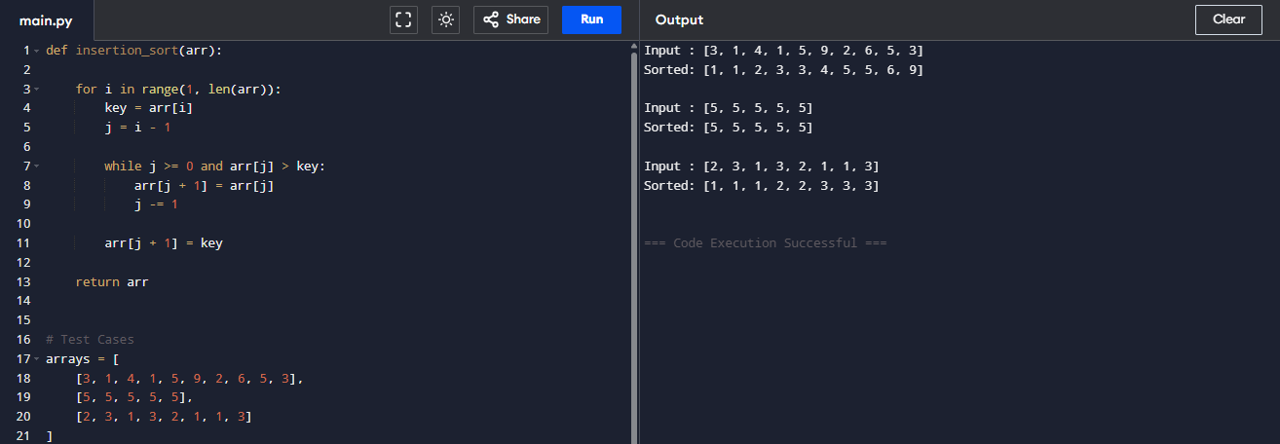
Result:
The program was executed successfully and the expected output was obtained.

Experiment 5
Aim:
As specified in the uploaded experiment sheet.
Algorithm:
1. Read input.
2. Apply the required algorithm.
3. Display the result.
Pseudocode:
START
Read input
Process using algorithm
Print output
STOP
Python Program:
def findKthPositive(arr, k):
current = 1
index = 0
while k > 0:
if index < len(arr) and arr[index] == current:
index += 1
else:
k -= 1
if k == 0:
return current
current += 1
# Test Cases
print("Example 1")
arr = [2, 3, 4, 7, 11]
k = 5
print("Output:", findKthPositive(arr, k))
print()
print("Example 2")
arr = [1, 2, 3, 4]
k = 2
print("Output:", findKthPositive(arr, k))

Sample Input:
Test Case 1:
Array = [2, 3, 4, 7, 11]
K = 5
Test Case 2:
Array = [1, 2, 3, 4]
K = 2
Sample Output:
Test Case 1:
9
Test Case 2:
6
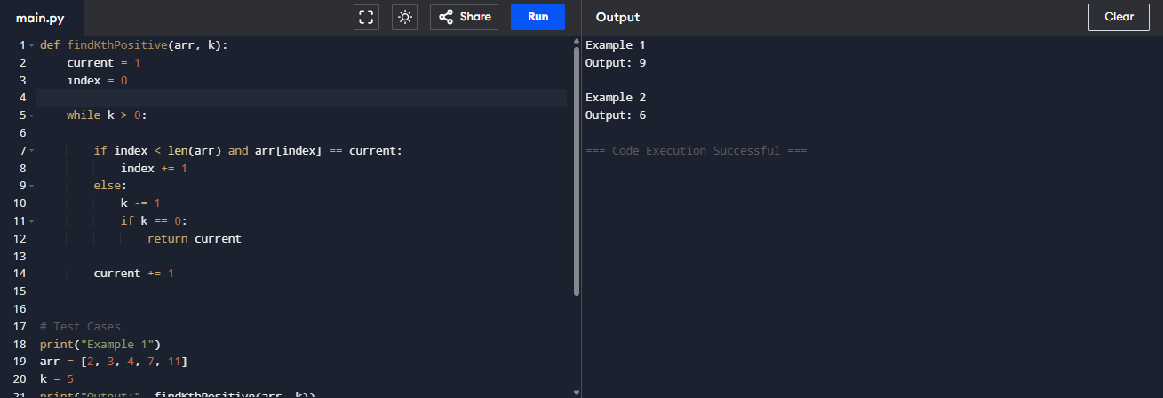
Result:
The program was executed successfully and the expected output was obtained.

Experiment 6
Aim:
As specified in the uploaded experiment sheet.
Algorithm:
1. Read input.
2. Apply the required algorithm.
3. Display the result.
Pseudocode:
START
Read input
Process using algorithm
Print output
STOP
Python Program:
def brute_force(text, pattern):
n = len(text)
m = len(pattern)

for i in range(n - m + 1):
j = 0
while j < m and text[i + j] == pattern[j]:
j += 1

if j == m:
return i

return -1

text = input("Enter Text: ")
pattern = input("Enter Pattern: ")

index = brute_force(text, pattern)

if index != -1:
print("Pattern found at index", index)
else:
print("Pattern not found")

Sample Input:
Enter Text: AABAACAADAABAABA
Enter Pattern: AABA

Sample Output:
Pattern found at index 0
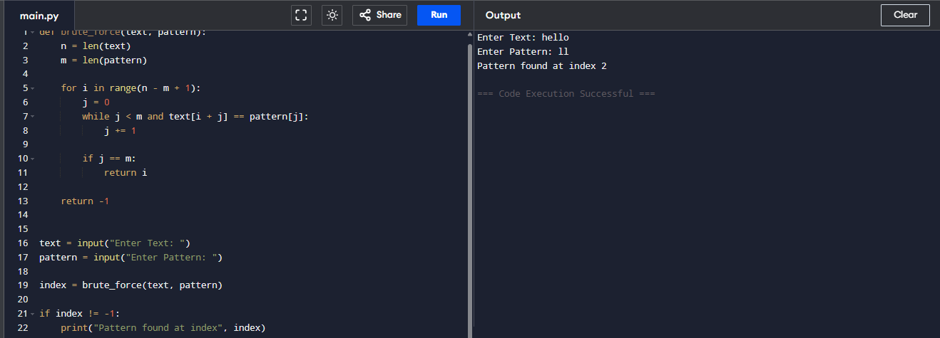
Result:
The program was executed successfully and the expected output was obtained.

Experiment 7
Aim:
As specified in the uploaded experiment sheet.
Algorithm:
1. Read input.
2. Apply the required algorithm.
3. Display the result.
Pseudocode:
START
Read input
Process using algorithm
Print output
STOP
Python Program:
import math
n = int(input("Enter number of points: "))
points = []
for i in range(n):
x, y = map(int, input().split())
points.append((x, y))
min_dist = float('inf')
pair = ()
for i in range(n):
for j in range(i + 1, n):
d = math.sqrt((points[i][0] - points[j][0]) ** 2 +
(points[i][1] - points[j][1]) ** 2)
if d < min_dist:
min_dist = d
pair = (points[i], points[j])
print("Closest Pair:", pair)
print("Minimum Distance:", round(min_dist, 2))

Sample Input:
Enter number of points:
4
2 3
12 30
40 50
5 1

Sample Output:
Closest Pair: ((2, 3), (5, 1))
Minimum Distance: 3.61

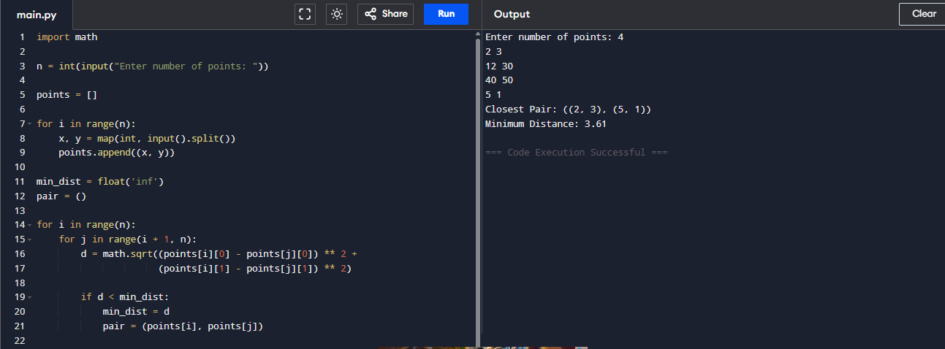
Result:
The program was executed successfully and the expected output was obtained.

Experiment 8
Aim:
As specified in the uploaded experiment sheet.
Algorithm:
1. Read input.
2. Apply the required algorithm.
3. Display the result.
Pseudocode:
START
Read input
Process using algorithm
Print output
STOP
Python Program:
from itertools import permutations

graph = [
[0, 10, 15, 20],
[10, 0, 35, 25],
[15, 35, 0, 30],
[20, 25, 30, 0]
]

n = len(graph)
vertices = list(range(1, n))
min_cost = float('inf')
for path in permutations(vertices):
cost = 0
k = 0

for j in path:
cost += graph[k][j]
k = j
cost += graph[k][0]
min_cost = min(min_cost, cost)
print("Minimum Cost:", min_cost)

Sample Input:
Distance Matrix
0 10 15 20
10 0 35 25
15 35 0 30
20 25 30 0

Sample Output:
Minimum Cost: 80
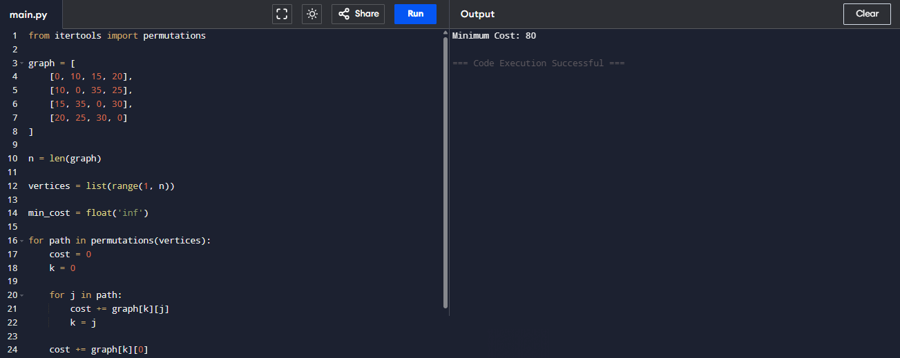
Result:
The program was executed successfully and the expected output was obtained.

Experiment 9
Aim:
As specified in the uploaded experiment sheet.
Algorithm:
1. Read input.
2. Apply the required algorithm.
3. Display the result.
Pseudocode:
START
Read input
Process using algorithm
Print output
STOP
Python Program:
def orientation(p, q, r):
return (q[1]-p[1])*(r[0]-q[0]) - (q[0]-p[0])*(r[1]-q[1])

def convex_hull(points):
if len(points) < 3:
return []

left = 0
for i in range(1, len(points)):
if points[i][0] < points[left][0]:
left = i

hull = []

p = left

while True:
hull.append(points[p])

q = (p + 1) % len(points)

for i in range(len(points)):
if orientation(points[p], points[i], points[q]) < 0:
q = i

p = q

if p == left:
break

return hull

points = [(0,3),(2,2),(1,1),(2,1),(3,0),(0,0),(3,3)]

print("Convex Hull:")
print(convex_hull(points))

Sample Input:
Points:
(0,3)
(2,2)
(1,1)
(2,1)
(3,0)
(0,0)
(3,3)

Sample Output:
Convex Hull:
[(0, 3), (0, 0), (3, 0), (3, 3)]

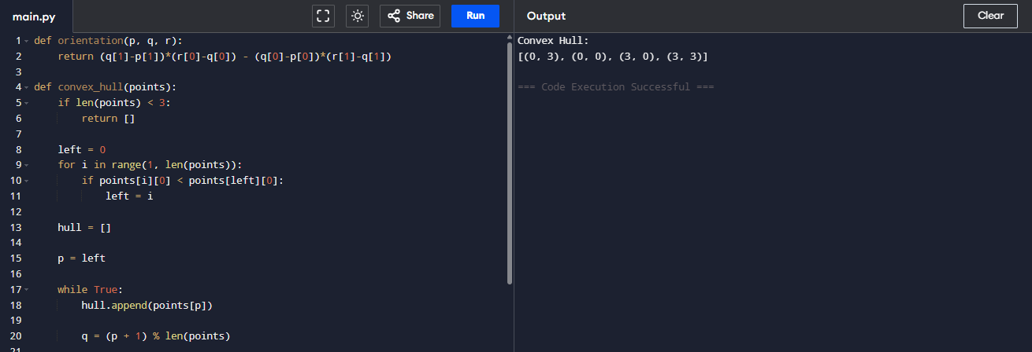
Result:
The program was executed successfully and the expected output was obtained.

Experiment 10
Aim:
As specified in the uploaded experiment sheet.
Algorithm:
1. Read input.
2. Apply the required algorithm.
3. Display the result.
Pseudocode:
START
Read input
Process using algorithm
Print output
STOP
Python Program:
from itertools import permutations

cost = [
[9,2,7],
[6,4,3],
[5,8,1]
]

n = len(cost)

workers = range(n)

min_cost = float('inf')
best = None
for perm in permutations(workers):
total = 0
for job in workers:
total += cost[perm[job]][job]
if total < min_cost:
min_cost = total
best = perm
print("Minimum Cost:", min_cost)
print("Assignment:", best)

Sample Input:
Cost Matrix

9 2 7
6 4 3
5 8 1

Sample Output:
Minimum Cost: 9
Assignment: (1, 0, 2)
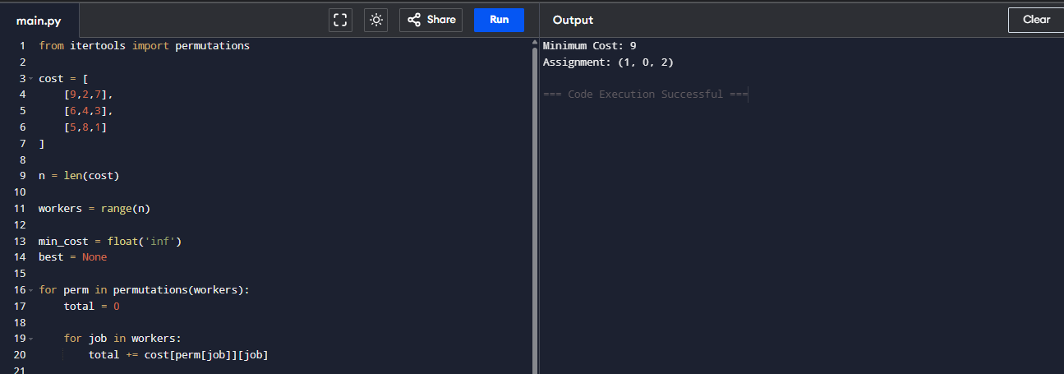
Result:
The program was executed successfully and the expected output was obtained.

Experiment 11
Aim:
As specified in the uploaded experiment sheet.
Algorithm:
1. Read input.
2. Apply the required algorithm.
3. Display the result.
Pseudocode:
START
Read input
Process using algorithm
Print output
STOP
Python Program:
def knapsack(weights, values, capacity):
n = len(values)

dp = [[0 for _ in range(capacity + 1)] for _ in range(n + 1)]

for i in range(1, n + 1):
for w in range(1, capacity + 1):
if weights[i - 1] <= w:
dp[i][w] = max(values[i - 1] + dp[i - 1][w - weights[i - 1]],
dp[i - 1][w])
else:
dp[i][w] = dp[i - 1][w]
return dp[n][capacity]
weights = [2, 3, 4, 5]
values = [3, 4, 5, 6]
capacity = 5
print("Weights :", weights)
print("Values :", values)
print("Capacity:", capacity)
print("Maximum Profit:", knapsack(weights, values, capacity))

Sample Input:
Weights = [2, 3, 4, 5]
Values = [3, 4, 5, 6]
Capacity = 5

Sample Output:
Weights : [2, 3, 4, 5]
Values : [3, 4, 5, 6]
Capacity: 5
Maximum Profit: 7
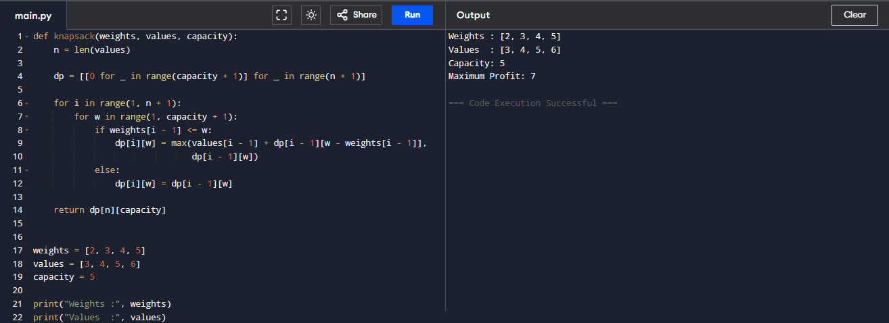
Result:
The program was executed successfully and the expected output was obtained.

Experiment 12
Aim:
As specified in the uploaded experiment sheet.
Algorithm:
1. Read input.
2. Apply the required algorithm.
3. Display the result.
Pseudocode:
START
Read input
Process using algorithm
Print output
STOP
Python Program:
items = [
(60, 10),
(100, 20),
(120, 30)
]

capacity = 50

items.sort(key=lambda x: x[0] / x[1], reverse=True)

profit = 0

for value, weight in items:
if capacity >= weight:
profit += value
capacity -= weight
else:
profit += value * (capacity / weight)
break

print("Items (Value, Weight):", items)
print("Maximum Profit:", profit)

Sample Input:
Items:
(60,10)
(100,20)
(120,30)
Capacity = 50

Sample Output:
Items (Value, Weight): [(60, 10), (100, 20), (120, 30)]
Maximum Profit: 240.0
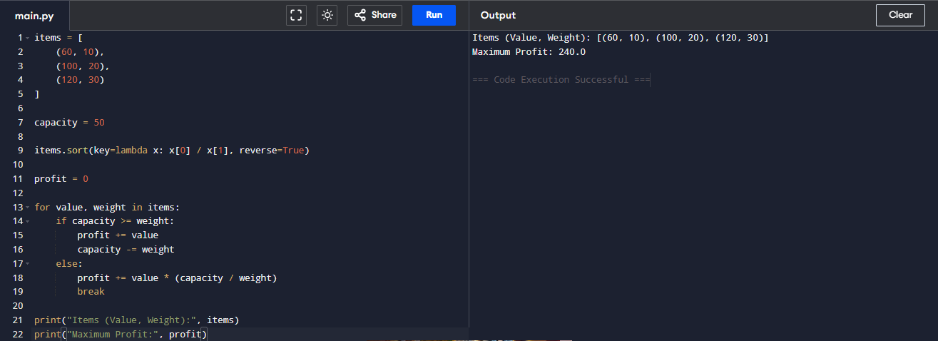
Result:
The program was executed successfully and the expected output was obtained.

Experiment 13
Aim:
As specified in the uploaded experiment sheet.
Algorithm:
1. Read input.
2. Apply the required algorithm.
3. Display the result.
Pseudocode:
START
Read input
Process using algorithm
Print output
STOP
Python Program:
import heapq
text = "AAABBCCCCDD"
frequency = {}
for ch in text:
frequency[ch] = frequency.get(ch, 0) + 1
heap = [[weight, [char, ""]] for char, weight in frequency.items()]
heapq.heapify(heap)
while len(heap) > 1:
low = heapq.heappop(heap)
high = heapq.heappop(heap)
for pair in low[1:]:
pair[1] = '0' + pair[1]
for pair in high[1:]:
pair[1] = '1' + pair[1]
heapq.heappush(heap, [low[0] + high[0]] + low[1:] + high[1:])
codes = sorted(heapq.heappop(heap)[1:], key=lambda p: (len(p[1]), p))
print("Character\tCode")
for char, code in codes:
print(char, "\t\t", code)

Sample Input:
Text = AAABBCCCCDD
Sample Output:
Character Code
C 0
A 10
B 110
D 111

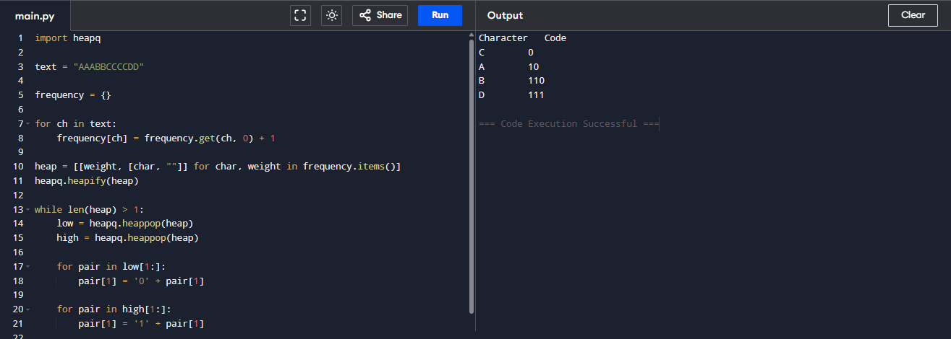
Result:
The program was executed successfully and the expected output was obtained.

Experiment 14
Aim:
As specified in the uploaded experiment sheet.
Algorithm:
1. Read input.
2. Apply the required algorithm.
3. Display the result.
Pseudocode:
START
Read input
Process using algorithm
Print output
STOP
Python Program:
N = 4

board = [[0] * N for _ in range(N)]

def is_safe(row, col):
for i in range(col):
if board[row][i]:
return False

i, j = row, col
while i >= 0 and j >= 0:
if board[i][j]:
return False
i -= 1
j -= 1

i, j = row, col
while i < N and j >= 0:
if board[i][j]:
return False
i += 1
j -= 1

return True

def solve(col):
if col >= N:
return True

for i in range(N):
if is_safe(i, col):
board[i][col] = 1

if solve(col + 1):
return True

board[i][col] = 0

return False

solve(0)

print("Solution for", N, "Queens:\n")

for row in board:
print(row)

Sample Input:
Number of Queens = 4
Sample Output:
Solution for 4 Queens:

[0, 0, 1, 0]
[1, 0, 0, 0]
[0, 0, 0, 1]
[0, 1, 0, 0]

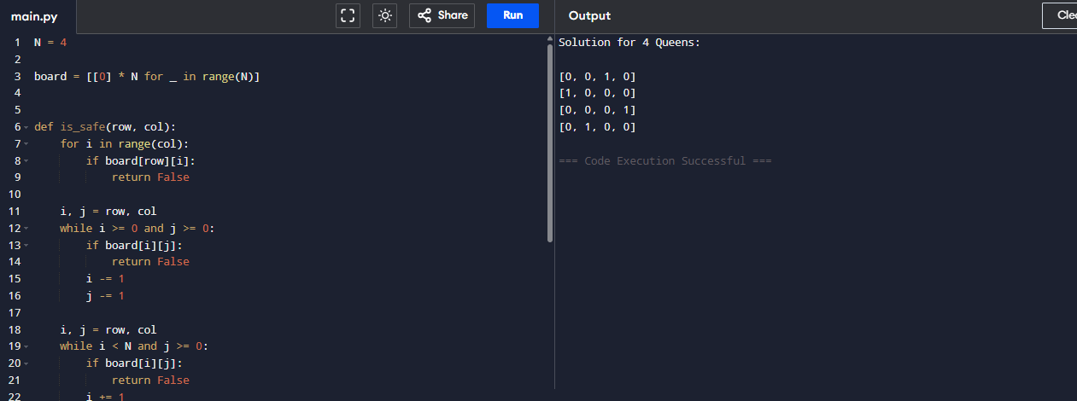
Result:
The program was executed successfully and the expected output was obtained.

